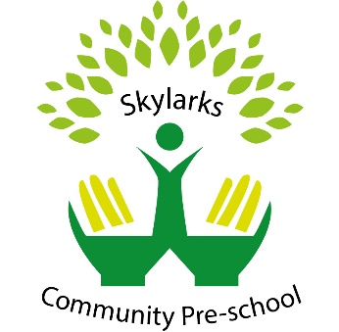

Promoting positive behaviour policy

We believe that children flourish best when their personal, social and emotional needs are understood, supported and met and where there are clear, fair and developmentally appropriate expectations for their behaviour.

As children develop, they learn about boundaries, the difference between right and wrong, and to consider the views and feelings, and needs and rights, of others and the impact that their behaviour has on people, places and objects. The development of these skills requires adult guidance to help encourage and model appropriate behaviours and to offer intervention and support when children struggle with conflict and emotional situations. In these types of situations key staff can help identify and address triggers for the behaviour and help children reflect, regulate and manage their actions.

This policy was adopted by | Skylarks Community Preschool | (name of provider)
On | 1st August 2022 | (date)
Date to be reviewed | 1st August 2023 | (date)
Signed on behalf of the provider | 
Name of signatory | Kathleen Thomson
Role of signatory (e.g. chair, director or owner) | Manager/Trustee

Date Reviewed | Changes | Signature
7th August 2024 | N/A
14th August 2025 | N/A

